Hill Lane Surgery
Newsletter
August 2019

Hello and welcome to our newsletter.

Dr Bentley will be retiring at the end of this month and we would like to wish him all the best in his retirement.
We do have two Doctors who have recently joined our surgery. Welcome Dr Martin Mayfield and Dr Corinna Engelke. (Dr Bentley’s current patients will be gradually moved over to our new Doctors).

We hope you are enjoying the English summer.

Our next newsletter will have useful information on your Flu jabs as it will be that time of the year again.

Kind Regards
Laura
Practice Administrator
Hill Lane Surgery

'Try the new NHS App’

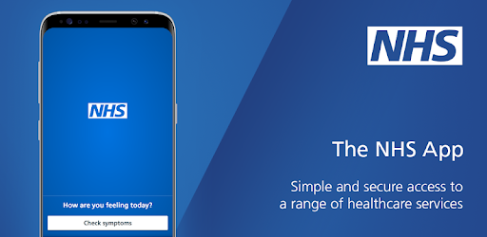

You can now use the new NHS App, a simple and secure way to access a range of NHS services on your smartphone or tablet.

You can use the NHS App to check your symptoms and get instant advice, book appointments, order repeat prescriptions, view your GP medical record and more.

If you already use our Hill Lane website, you can continue to use it. You can use the NHS App as well.

For more information go to www.nhs.uk/nhsapp

(You might also need to review existing website content to make sure it covers the different options patients have to connect with online services.)

https://www.jostrust.org.uk/about-us?gclid=CjwKCAiAhfzSBRBTEiwAN-ysWIVlPzyexe1oe2o5AZ3ZG0S500W5xKV9ymS5hBKyq90IyKuUZhqHARoCWPkQAvD_BwE

Please call the surgery to book an appointment if your smear is due. Please click on the link above for more information, and answers to lots of questions about cervical screening.

"A smear test lasts 5 minutes. The Impact of cervical cancer lasts a lifetime"

Attend your smear test.

Reduce your risk.

Podiatry Drop In Service

The Podiatry Drop in Service, for anyone who requires information or advice.

‘Do you have problems with your feet?’, then you may find it useful to talk to a podiatrist at one of the local drop in sessions.

Drop in session run from 9am to 12pm and 1.30pm to 4pm at the following locations - please be aware that no treatment will be undertaken unless considered an emergency:

Contact number for both (single point of access): 0300 300 2012 or email: snhs.solentnhspodietry@nhs.net

Adelaide Health Centre, Western Community Hospital, William Macleod Way, Southampton SO16 4XE

Dates for 2019

Monday 5th and 19th August 2019

Monday 9th and 23rd September 2019

Monday 7th and 21th October 2019

Monday 4th and 18th November 2019

Monday 2nd and 16th December 2019

Monday 30th December 2020 (AM only)

Monday 13th and 27th January 2020

Monday 10th and 24th February 2020

Monday 9th and 23rd March 2020

Bitterne Health Centre, Commercial Street, Southampton, SO18 6BT

Monday 2nd, 16th and 30th September 2019

Monday 14th and 28th October 2019

Monday 11th and 25th November 2019

Monday 9th December 2019

Monday 23rd December 2019 (AM only)

Monday 6th and 20th January 2020

Monday 3rd and 17th February 2020

Monday 2nd, 16th and 30th March 2020

